Portraits of the Pandemic Art: Art History’s Response to Crisis
In light of the current global pandemic, let us look at the visual images past and present that artists have produced during times of plague, war, economic hardships and social injustice. Perhaps in their work we can find understanding about our current situation.

Art has played a vital role interpreting humanity’s experience with crisis. Artistic periods and movements often transcend individual events, however throughout history artists have portrayed life altering events with their own unique style and vision.

Historically, the art that emerges from a crisis is sober and confronting, not meant to entertain or be decorative. It is created to reveal and reflect and once the darkness has passed offers us an opportunity to see things in a new light.

Black Death
The Black Death was a devastating global pandemic of bubonic plague which swept through most of Europe and Asia, killing somewhere between 75 and 200 million people. Despite peaking around 1350, it continued to spread well into the 17th Century. To this day, it remains the single most deadly pandemic in human history.

The Black Death coincided with the Renaissance, one of the most prolific times in European art history. It marked the transition from medieval Christian iconography to a more Humanistic philosophy.

Late Medieval and early Renaissance artists viewed the plague as death itself. Since one rarely recovered, the Bubonic Plague was literally a death sentence. Dark humor was a perverse byproduct of the Black Death in which sickness and death were viewed through a ghoulish lens.

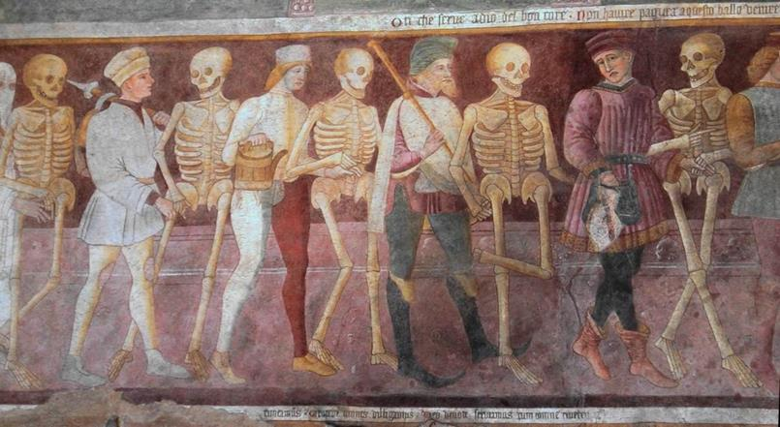
Painted on the side of the Oratorio dei Disciplini in Clusone, Italy in the 15th century, the haunting mural The Triumph of Death by Giacomo Borlone de Burchis, celebrates the capricious nature of death. In this fresco, men dance with skeletons as they approach their death. Such depictions served to remind both the poor and powerful that death will come to all of us.
Giacomo Borlone de Burchis, The Triumph of Death, 15th c.

Another variation on the theme was painted by Pieter Bruegel the Elder well after the Bubonic Plague had peaked in Europe. However, millions of people still feared the deadly disease. The Triumph of Death (1562) depicts skeletons marching through the landscape, leaving devastation in their wake.

Spanish Flu
Though not as devastating as the Black Death, the Spanish Flu (present from January 1918 to December 1920) was the first major pandemic of the 20th Century. It infected 500 million people globally which comprised 27% of the world population at the time. The death toll is estimated to have been anywhere from 17 million to 50 million, and possibly as high as 100 million.

The Spanish Flu has long been overshadowed by World War I. For many, the two events combined with political upheavals (rise of Communism) and social issues (gender and income inequality) to create a perception of the world as chaotic and hopeless. A sense of meaninglessness spread, and people started to lose faith in their governments, existing social structures and accepted moral values. The art movements that came out of this period explored this hopelessness and uncertainty.
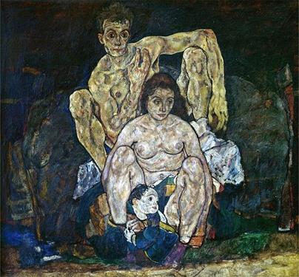
Austrian born Egon Schiele was a major figurative painter of the early 20th century. His works were intense and disturbing with their unconventional depictions of the human body and unapologetic sexuality.

Early in 1918, Schiele began one of his last paintings, a portrait of his family. He completed three figures, Schiele with his wife, Edith, and their unborn child. The Family (1918) would never be finished. Edith succumbed to the Spanish flu in the 6th month of her pregnancy. Three days later Egon died too.
Egon Schiele, The Family, 1918
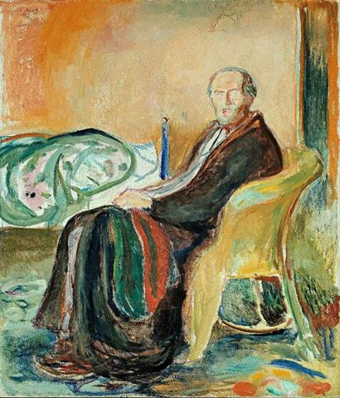
Norwegian painter Edvard Munch also found inspiration in the disease. The artist made Self-Portrait With the Spanish Flu and Self-Portrait After the Spanish Flu (both 1919), detailing his own experience contracting and surviving the illness. In the portrait after his recovery Munch appears gaunt, wrapped in a dressing gown and blanket. According to one account, Munch discussed the painting with his personal physician, remarking that he sought to portray the “odor of death.”
Edvard Munch, Self-Portrait With the Spanish Flu, 1919
SARS
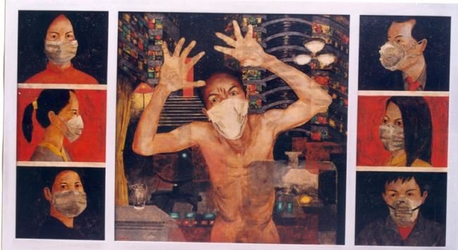
SARS (Severe Acute Respiratory Syndrome) was a relatively short lived (2002-2004) but highly contagious virus, infecting 8,000 people in dozens of countries. For months, people isolated themselves from the rest of society for fear of catching the deadly disease. The intense media coverage helped heighten measures to combat SARS and ended up saving thousands of lives. SARS had a profound impact on the people of Southeast Asia, affecting its economy and introducing the cultural practice of wearing masks outside of the home.
Tran Tuan Long, A Cluster of 17 Cases: Blast Theory, 2018

Vietnamese artist Tran Tuan Long is a Vietnamese artist whose work focuses on Vietnam’s cultural past. SARS, a lacquer painting, demonstrates the impact that SARS had on an entire region. In this painting, Tran recreates a series of men and women wearing masks. Their expressions range from stoic to fearful. In the center, a naked man in a mask embodies the anxiety, chaos, and danger of the disease.

In 2018 Blast Theory, the first artists-in-residence at the World Health organization, created the multi-media installation, A Cluster of 17 Cases, based on the SARS epidemic. It was inspired by the stories of 17 unsuspecting people who stayed on the same floor of hotel on a single night in February 2003. These people were subsequently identified as spreading the SARS virus to at least 546 people around the globe. It is a chilling and profoundly relevant investigation of how a small cluster can quickly become a super spreader event.

War
Art can be called into service as propaganda to promote war or oppose it. The theme and mood of art about war has shifted over the past two centuries from heroic scenes rich in religious imagery to shocking images of brutality and pathos.

Haunting, macabre, and poignant, The Disaster of War, a series of 82 etchings by Spanish artist Francisco Goya, is a bold anti-war statement and powerful reminder of man’s inhumanity to man during the time of war.

Created between 1810 and 1820 art historians view the series as a protest against conflicts between Napoleon's French Empire and Spain. The etchings are often categorized into three groups—war, famine, and political allegory. Goya used realistic expressions, clothing, and settings that give authenticity and poignancy to the scenes of starvation, torture, and atrocities.
Pablo Picasso, Guernica, 1937

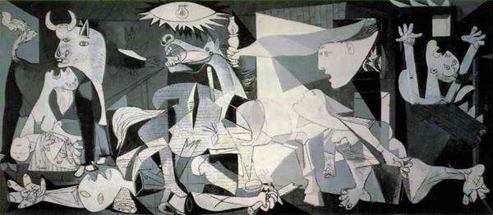

Inspired by Goya, fellow Spaniard Pablo Picasso’s Guernica is considered one of the most powerful anti-war paintings in history. Painted in 1937, the 20-foot-long-mural is an anguished response to the bombing of Guernica, a town in northern Spain during the Spanish Civil War. With its tones of grey, harsh angles and geometric distortions, Picasso shows the horrors of war though the suffering of innocent civilians, confronting the viewer in a painfully confined space of prolonged agony.

American artist and ex pat, John Singer Sargent, best known for his sumptuous portraits of Gilded Age aristocracy was commissioned by the British Government to “contribute the central painting for a Hall of Remembrance for the World War.” He found his subject in the summer of 1918 in a British dressing station in France that was treating soldiers blinded by a mustard gas attack.

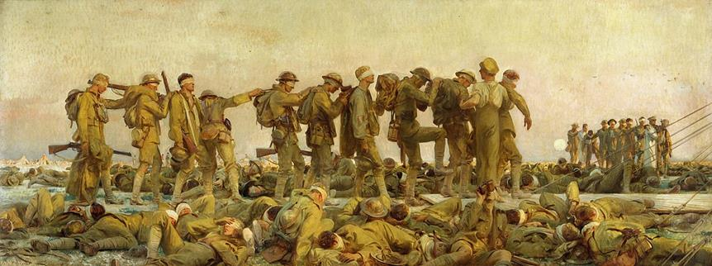
John Singer Sargent, Gassed, 1918-19

Gassed, an epic (9’ x 21’) freize-like composition depicts the impact of modern chemical warfare and the devastating human toll to young men in uniform. In an ironic juxtaposition, a football (soccer) game is being played in the background seemingly unaware of the damaged and blinded parade of Tommies (the nickname of British soldiers).

Great Depression
American artists during the Great Depression had to wrestle with the idea that Western-style democracy and its promise of prosperity was not working for many people. Artists sought to depict the hardships faced by the American people and used their images to galvanize social change.
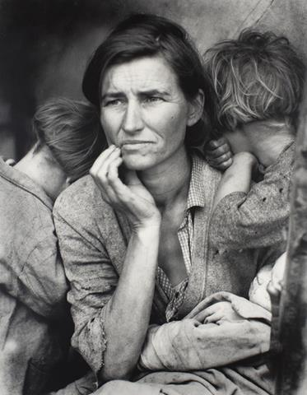
Photographer Dorothea Lange called attention to the economic adversity faced by the rural poor. As an employee of a New Deal program designed to provide aid to and raise public awareness for farmers, Lange documented the lives of migrant formers forced to move west as a result of the Great Depression and the devastation of the Dust Bowl. Her haunting image Migrant Mother, Nipomo, California showed a starving mother desperately trying to feed her seven children.

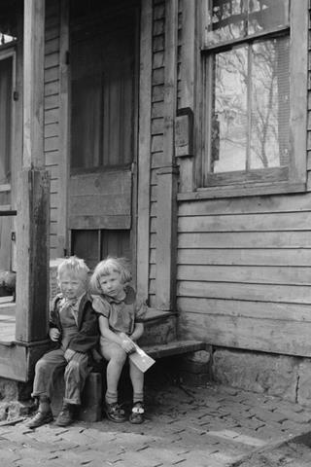

Dorothea Lange, Migrant Mother, Nipomo, California, 1936

As part of the Farm Service Administration, photographers and writers were hired to report and document the plight of poor farmers and smaller communities during the Depression. Minnesota born photographer John Vachon visited Dubuque in the spring of 1940 and his prints are a visual record of our city at that time.
John Vachon, Children Who Live in the Slums, 1940

HIV/AIDS
HIV/AIDS swept across the United States and the rest of the world in the 1980’s and early 1990’s. Today, 75 million people have been infected with HIV and about 32 million have died from AIDS since the start of the epidemic. People of any age, gender, or sexual orientation can catch the disease and there is no cure or vaccine, however antiretroviral treatments can slow the course of the disease. That said, close to 13,000 people I the United States with AIDS die each year.

The visual vocabulary of HIV/ AIDS is bold and brash and often overtly political. In 1987, six gay activists in New York formed the Silence = Death Project and designed a poster for it, using the pink triangle as the logo, a well-established pro-gay liberation symbol in the United States at that time. The six activists later founded ACT UP, a grassroots political group working to end the AIDS pandemic.

Keith Haring began his career as a New York street artist and by the mid-1980s gained international attention as one of the leaders of pop art. As an openly gay artist, Haring frequently used his art to speak out on politics and issues like homosexuality, poverty, and HIV/AIDS.
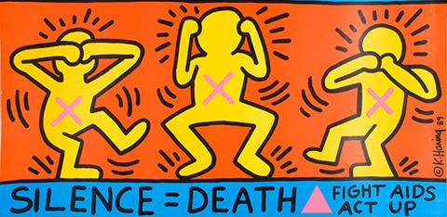
Diagnosed with AIDS the previous year, Haring coopted the “SILENCE = DEATH” slogan, “ACT UP” name, and pink triangle in his 1989 work Ignorance = Fear / Silence = Death (1989). The poster depicts three figures gesturing “see nothing, hear nothing, say nothing”. This implied the struggles faced by those living with AIDS and the challenges posed by individuals or groups that fail to properly acknowledge the epidemic and chose to look the other way.
Keith Haring, Ignorance=Fear / Silence=Death, 1989

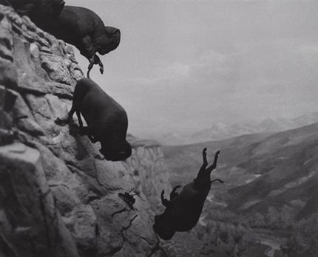
David Wojnarowicz was an American painter and political activist who used his art to comment on the experience of gay men in America. His work became more politically motivated following his HIV diagnosis in 1987.

Untitled (Falling Buffalos) is a haunting response to the AIDS crisis of the 1980s. In this photomontage a herd of buffalo are falling off a cliff to their deaths. Wojnarowicz’s image draws a parallel between the AIDS crisis and the mass slaughter of buffalos in America in the nineteenth century. With its sense of doom and hopelessness it reminds viewers of the neglect and marginalization that faced victims of HIV/AIDS at the time. Wojnarowicz died of the disease in 1992.
David Wojnarowicz, Untitled (Buffalo), 1988-89

#MeToo Movement
Art has always been a vehicle for artists to express their concerns or outrage about inequity in society, and the #MeToo movement has emerged as a platform for women around the world to share their stories and shed light on the physical and emotional pain of sexual assault and harassment.

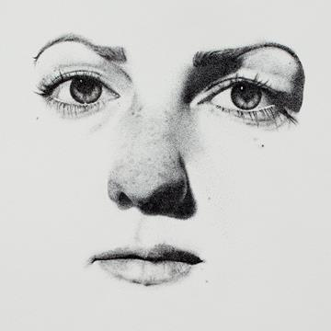
American activist Tarana Burke started the #MeToo movement in 2006 to help survivors of sexual violence find “pathways to healing”. Since it was popularized on Twitter the movement has attracted waves of culturally responsive and sensitive work by artists of all types seeking a valuable and safe space for creative expression. Their work brings complexity of experience, compassion and understanding to the conversation.

Los Angele based artist Claire Salvo felt inspired to create her Stippling MeToo portrait after experiencing sexual assault. Her work recounts the stories of nine women who have been sexually assaulted. Her hope, says Salvo, “is that women find community, connection, and power in these stories.”

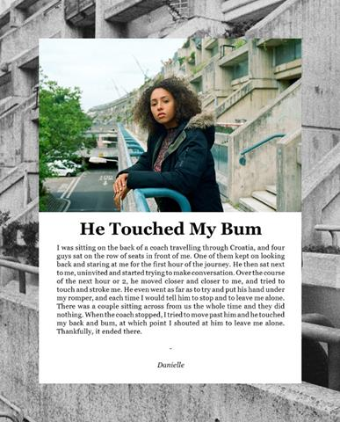
Claire Salvo, Stippling MeToo, 2017

Photojournalist Eliza Hatch created Cheer Up Luv, a series of photographs and interviews retelling women’s stories of sexual harassment. Says Hatch, “I started the project as a way of showing my male friends the kind of things we would have to put up with…however as the project grew, it became more than just raising awareness.” Today, Cheer Up Love is a global platform for women to find solidarity and strength.
Eliza Hatch, Cheer Up Luv, 2017

Black Lives Matter
Art makes social justice visible and documents movements. It has the ability to rally support and create a sense of community in times of crisis. In recent years, as the Black Lives Matter movement has gained momentum, graffiti has increasingly been used to advance its vision. The inherently political medium’s storytelling powers have become a way for communities to raise awareness, express themselves, and educate the public.
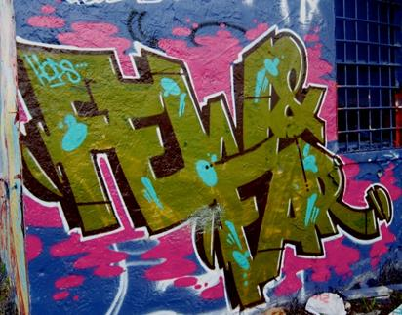
The link between graffiti, street art and activism led to the creation of organizations that harness the power of visual imagery and language to work towards social change. Cleveland’s Graffiti HeArt, funds art scholarships and urban development projects within communities. fewandfarwomen, organized in 2011 is an international group of women who share a commitment to creativity, education and social justice as they “beautify streets, draw, paint and teach all over the globe”.
fewandfarwomen, graffiti, 2019

Explains its founder, Meme, “Art on the streets is a way of storytelling. It has often been the visual counterpart to many movements, as murals and graffiti respond almost immediately to our constantly changing times.”

Foley Square in Lower Manhattan and Harlem featured multicolored letters of Black Lives Matter replete with imagery related to Black people who were killed by the police, as well as vibrant symbols of freedom, hope and joy.

In Cincinnati, the art appears in the red, black and green of the Pan-African flag, with silhouettes, phrases and textured designs filling the letters. In Jackson, Mich., it was designed it in a graffiti-style font. In Portland, Ore., the letters contained a timeline of historical injustices in the state.

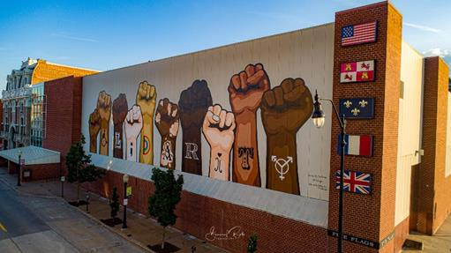
Closer to home, in a response to nationwide calls for change regarding the treatment of and policies towards communities of color, the City of Dubuque Arts and Cultural Affairs Advisory Commission reaffirmed its commitment towards making Dubuque a more inclusive and equitable community by creating a mural celebrating inclusivity and diversity.
Shelby Fry, Solidarity Mural, 2020, photo by Robert Felderman

Painted by over 75 volunteers on the east side of Five Flags Civic Center on Main Street in downtown Dubuque, the Solidarity mural, is a visual embodiment of that message and demonstrates the City's support for Black Lives Matter and its ongoing efforts to implement positive change.

The University of St. Thomas in Minnesota created a database for the George Floyd, an African American man killed by police during an arrest in Minneapolis as well as Anti-Racist Street artworks created around the world. The database serves as a future resource for scholars and artists in hopes that this shameful moment in history is not forgotten.

COVID-19 Pandemic
Artists and arts organizations stepped up immediately after the onset of the COVID-19 pandemic with work that was about creating connection, strengthening communication, and helping people cope with the stress.

“Especially at times when trust in some government sources of information is in question, the arts can facilitate communication to diverse audiences quickly and widely,” says Jill Sonke, director of the Center for Arts in Medicine. “Artists are trusted community members and influencers. They can make critical information more personally and culturally relevant, understandable and memorable.”

In the United States and around the world, the COVID-19 pandemic has shed light on our economic, social, and political systems. We are seeing how systemic racial inequality is putting people of color at a higher risk during the pandemic.
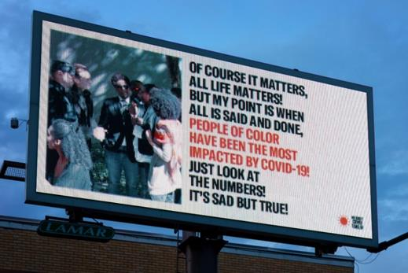
RESIST COVID TAKE 6! is a public art campaign by photographer Carrie Mae Weems that communicates healthcare messaging and raises awareness about this disproportion. The artist promotes preventive measures to the people of Syracuse, New York, in form of billboards, PSAs on local radio stations and social media platforms, as well as items such as tote bags, posters, flyers, magnets, etc. The title is an allusion to the recommended six feet of separation in social distancing. Weems’ motivation for the project was, “How can I use my art and my voice as a way of underscoring what’s possible and bring the general public into a conversation, into heightened awareness of this problem to better the community in which I live?’”
Carrie Mae Weems, RESIST COVID TAKE 6!, 2020

Graffiti and street artists and muralists are taking over public spaces during the pandemic, using their art to express beauty, support and dissent. A colorful, geometric mural by Milwaukee artist Mauricio Ramirez depicts a front-line medical worker in prayer. In Dublin, a neon-hued psychedelic coronavirus graces a wall, painted by SUBSET, an artist collective that focuses on social issues. In Berlin, there's a mural of Gollum from Lord of the Rings worshipping a roll of toilet paper.
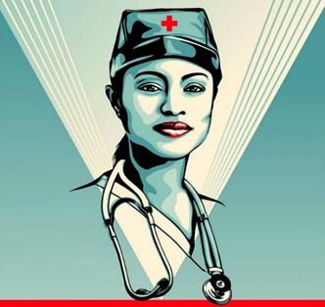
Shepard Fairey, the street artist who became internationally known when he designed the Hope poster for Barack Obama’s 2008 presidential campaign has created works honoring healthcare workers. He is also collaborating with the design lab Amplifier to commission artists to create public-health and safety messages as part of a COVID-19 campaign.

Lessons Learned?
What can we learn by looking at the history of art in response to crises past and present? Crisis is a disrupter. It forces us to rethink hidebound attitudes and patterns. Viewing art can provide a framework for how to feel and what to do when we have difficulty making sense of the present. Art becomes part of our collective memory. It acts as both diagnostic and directive. It will, as it always has, exist to instruct and inspire us as we move into the future.
Shepard Fairey, Guts Not Glory, 2020

